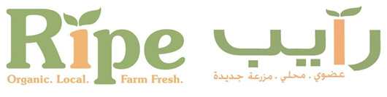
Ripe Markets | Bookings form
Please fill out your booking requests below:

 | Market Member Name (company):
 | Have you paid the new Season Annual Registration Fee: | YES | NO
 | If NO please fill out the form below and send back to us with this booking form. (Registration fee is renewed yearly.)
 | Name of Market | Dates and Table Package (Seed, Blossom, Harvest, Live cooking or Food Truck)
 | Town Centre Jumeirah
 | Omega Dubai Ladies Classic, Emirates Golf Club
 | Omega Dubai Desert Classic, Emirates Golf Club
 | D3, Design District
 | Golden Mile Galleria, The Palm

Ripe Markets | Market Card Payment & Registration form

Welcome to the Ripe Markets Registration! whether this is your first time registering with us or you are one of our valued returning Ripe Members, we would like to thank you for taking the time to come and join our community. Once you have filled out the following registration form, Ripe we will be delighted to secure your space and book you into our new season markets, subject to availability.
Registration Fees are below:
Arts & Craft Members: 300AED
Food Members: 550AED

MEMBER COMPANY NAME
MARKET MEMBER NAME
CONTACT EMAIL
CONTACT MOBILE NUMBER

NAME ON THE CARD
CARD NUMBER
CREDIT CARD EXPIRY DATE

PAYMENT FOR & AMOUNT
TOTAL AMOUNT
SIGNITURE & DATE

I authorize Ripe Fresh Trading LLC to take payment for the participation in Ripe Markets on the below credit card for my registration fees and any outstanding dues for any upcoming bookings.

