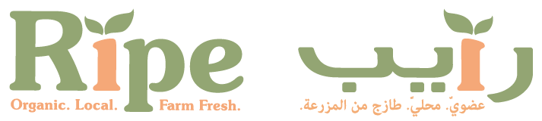
*FOR IMMEDIATE RELEASE*
Ripe Organic Kitchen
The Ripe Organic Kitchen is where the Ripe foodie magic happens. This is where we taste test new produce from the farms and new products we stock in the Ripe Organic Farm Shop. This is where we whip up new healthy organic recipes using the best produce in town. This is where we cosy up as a team over a lovely cup of tea or delicious meal and chat about how we can bring the community together to support local farmers and artisans.
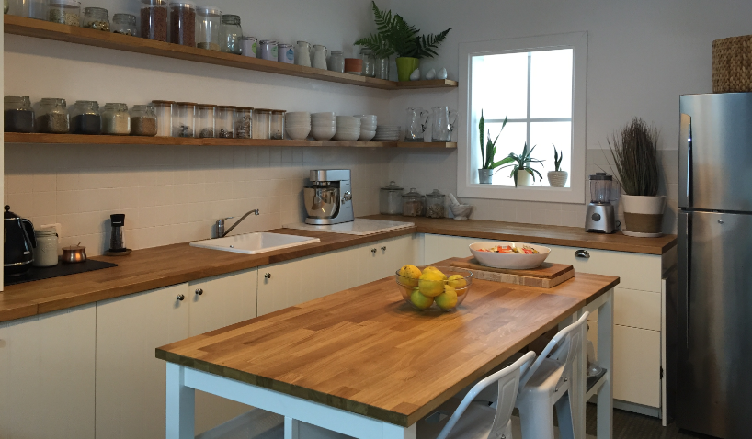
Supported by Kenwood and De’Longhi, our kitchen is fully-equipped with some of the best tools in town to help us prepare healthy, delicious meals. We’re open to chefs and bloggers as a space where they can come create recipes, arrange photoshoots and filming, host workshops, and connect with the community.
The Ripe Organic Kitchen can be found at The Collective, a new addition to the burgeoning art and culture scene in Dubai’s Al Quoz area, set within The Courtyard. A hub for creatives, artists, taste-makers and trend-setters, The Collective is a place to explore, shop and eat in a unique setting that is like no other in Dubai.
You can also expect food workshops and demos, regular Ripe Organic pop-ups, and merchants & makers markets taking place in the al fresco Courtyard setting.
To chat about what you would like to do in the Ripe Organic Kitchen, please contact us on 04 315 7000 or email marketing@ripeme.com.
-Ends-
For all press inquiries or to request an interview with Becky, please contact Janine on 04 315 7000 or email PR@ripeme.com. If you would like more information about Ripe visit www.ripeme.com | facebook.com/ripeuae | Instagram.com/ripefresh |Instagram.com/ripemarket
Notes for Editors
- High resolution images of the Ripe Market are available. Contact us with your image requirements.

- Background information concerning Ripe, what we do and our activities can be found below.
Ripe background information
Ripe Organic
Ripe is the UAE’s leading provider of fresh, local organic fruits and vegetables. We’re a team of food fanatics, on a mission to educate and engage the community in our passion for local, organic and seasonal produce.
At the top of the tree is Dubai-based entrepreneur, Becky Balderstone, who launched Ripe in the summer of 2011 when she realized that she couldn’t source seasonal, organic, local fresh produce boxes in the UAE, like she could in the UK and elsewhere. It was then that the Ripe seed was first planted and the Ripe Box was born.
Several years and many hours of hard work later, the Ripe team is pioneering the healthy eating revolution in the UAE, with a business that is now firmly on the region’s list of ‘brands to watch’ for 2015.
Ripe provides produce from local UAE farms, handpicked for their organic farming techniques, eco-friendly operating systems and local and international organic certifications. Produce is picked within 48 hours of being sold to ensure taste and freshness is never compromised and thanks to the elimination of air-freight and storage costs, Ripe is affordable for all.
Ripe Organic Shop
Situated in the heart of Al Manara, Dubai, our gorgeous little farm shop is packed full of delicious-ness. From fresh organic fruit and veg, free range organic eggs, dairy and dairy alternatives, to gluten free baked bread, superfoods, local honey, dried goods, tea and cleaning items, we have it all!
Opening hours
Open 7 Days a week | Sunday - Thursday, 8am-8pm | Fridays & Saturdays, 9am-5pm
Read more about our Organic Retail Shop: http://www.ripeme.com/ripe-farm-shop

Ripe Organic Home Delivery

Eating organic couldn’t be easier when you order with Ripe. Give us a call, email us or order online to receive next day door to door delivery.

T: 04 380 7602 | orders@ripeme.com | www.ripeme.com

Read more about our Organic Home Delivery: http://www.ripeme.com/order

Ripe Organic Community – Raising with Ripe
Ripe is not just a business but a catalyst; we’re planting seeds throughout the community to ensure we not only support and nourish the local farmers, but provide a platform for young, talented artisans in the UAE to grow and develop. And we believe educating the next generation of eaters, growers, makers and bakers is just as important. Which is why we launched Raising with Ripe, a fundraising initiative for schools to encourage healthier eating among children. We work together with schools to Pop-up our organic fruit and veg stand. 10% of the money taken goes back to the school to plant a vegetable garden for student.
Ripe Chefs Club
The Ripe Chefs Club is a one-stop spot to help professional chefs reconnect with their roots, by providing them with local, organic produce for personal use, and giving them chef-worthy perks, while connecting them to the Ripe foodie community. Benefits include:
- 10% discount on Ripe orders above 150 AED (discount can only be availed by calling our office to place your order)
- Exclusive farm visits and education about Ripe products and organic, local, seasonal farming
- Opportunity for chefs to showcase themselves at our markets, including workshops or a live cooking station
- Opportunity for chefs to feature on our blog and social media, including interviews, recipes, foodie advice, health advice, etc
- Opportunity to participate in Ripe competitions and events to showcase themselves
- Access to particular products / those not easily found in market

Ripe Markets
Taking place on a weekly basis, The Ripe Markets are a unique alfresco shopping experience in some of the UAE’s best parks and venues. Bringing together the local and expat community to support local SME businesses, the Ripe Markets feature some of the hottest and most talented foodies, artisans, designers, jewellers, entertainers and musicians in town. There’s also a mixture of activities that add to the fantastic market vibe like live musicians, workshops, yoga sessions, sports activations, and so much more!
Ripe Events taking place this season:

Dubai
- Times Square Centre - Every Saturday, from 9am – 3pm, until end October 2016
- Le Meridien Mina Seyahi – Every Wednesday, from 2pm – 9pm, from 12th October
- Al Barsha Pond Park – Every Saturday, from 3pm – 9pm, from 15th October
- Zabeel Park – Every Friday, from 9am – 3pm, from 21st October

Abu Dhabi:
- Jones The Grocer, Al Raha Gardens – Every Monday, from 10am – 1pm (Ripe Organic stand only)
- The Collection, St Regis Saadiyat Island Resort – Every Friday, from 10am – 3pm (Ripe Organic stand only)
- Umm Al Emarat Park – Every Saturday, from 3pm – 10pm

About De‘Longhi Group
De’Longhi: Better every day
De’Longhi’s unique combination of quality, innovation and design has made the company a world leader in domestic appliances.
Besides being No.1 in the world in espresso coffee machines, De'Longhi meets a wide range of domestic requirements, heating and cooling your home, cooking your meals, steaming your suit. De’Longhi aims to offer consumers innovative home appliances with a distinctive combination of style and performance, always turning "the everyday" into something special.
The De’Longhi Group is present in 33 countries with direct commercial subsidiaries and sells its product to countries all over the world, remaining committed to creating innovations that bring convenience and style into every customers' home making the everyday better. For more information seehttp://www.delonghi.com/en-meia
About Kenwood
At Kenwood we proudly design and manufacture cutting edge, stylish and efficient kitchen appliances since 1947 within the UK. As the expert in food preparation, our focus is to ensure every Kenwood product enhances your enjoyment of cooking, producing consistently high quality results with the greatest of ease. Which ever Kenwood product you choose, you can be sure to create the perfect dish every time.
Be inspired
With the confidence to prepare great food for all occasions, you will find the versatility of our products really help you to create more. You will quickly discover new ideas, new dishes and new recipes to make every meal special.
Thanks to its timeless design, your Kenwood product will continue to grace your kitchen over generations. Our appliances’ looks are as durable as their quality build, guaranteeing an astute investment that will continue to delight years after years. For more information see http://www.kenwoodworld.com/en-ae

