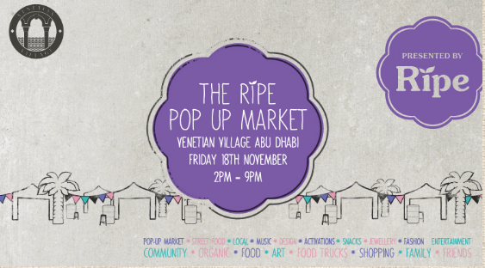

Dear

Vendor Information Pack

We are so glad to be welcoming you to the Ripe Pop Up Market at Venetian Village taking place on Friday 18th November from 2pm – 9pm

Upon arrival please ask one of the Ripe Team to show you to your position. Please make sure you have a copy of your booking with you so we can help you to get to your position as quickly as possible.

ARRIVALS & DEPARTURES – LOCATION MAP

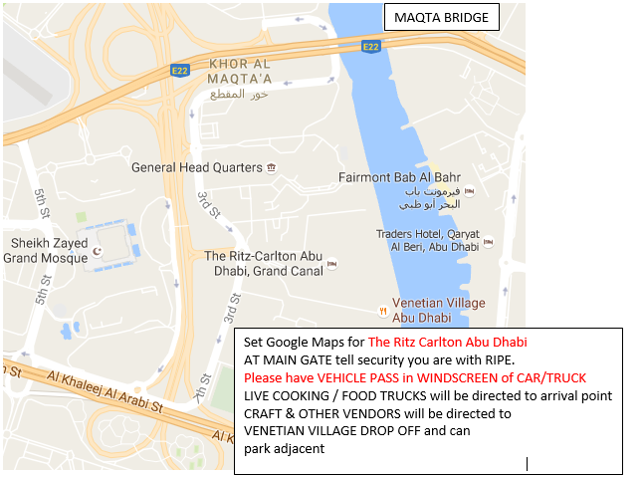

*** Please ensure you have trolleys to deliver to your spot from your drop off point ***
*** Please remember to bring battery operated lights for your stall ***
All vendors must be ready 30 minutes before the Market opens at 2PM
ARRIVAL & DEPARTURE – SITE PLAN
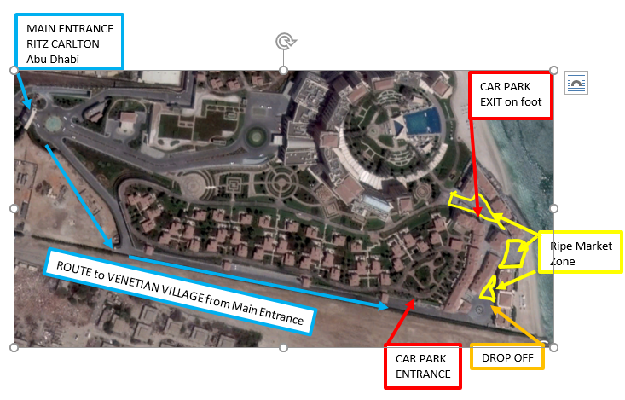ARRIVAL & DEPARTURE - TIMINGS
In order to have a smooth arrival please ensure you allow 30 minutes for Check In at Main Entrance, unloading at drop off point, parking your car. Please ensure you have Emirates ID on you at all times. Any member of your team may be refused access without one. NO EXCEPTIONS.
.
ALL VENDORS can arrive to drop from 11:30AM onwards
- You are arriving at a Drop Off point only. Please ensure that you unload as quickly as you can so that the car /van/truck behind you can do the same.
- Please follow the instructions of security and Ripe staff.
- Please ensure you have your own trolleys and stick to the path from the drop off point.
- Please ensure that you have battery operated lights.
- Please do not start to pack up until 9PM.

Please ensure that visitors to your stand are made aware that ALL VISITOR PARKING is at The Ritz Carlton Parking.

ON SITE MOBILE for assistance
+971 52 693 3731

FOOD VENDORS

All companies selling food including pre-packaged food sold in sealed containers, providing food sampling, live cooking stations and food trucks must have a valid UAE Trade Licence.

Relevant to the food being sold or prepared. It is your responsibility to obtain the proper permits to take part in the event and Ripe will not be held responsible for any fines for not carrying out proper procedures.

Live Cooking, Sampling and Food Truck vendors handling food on site at any Ripe Market must have a valid Health Card and conform to UAE Food Control regulations. Please ensure the following:

- Those handling food should wear a hair net or hat properly and wear gloves as required under UAE Food Control Law
- All cooking takes place under the canopy of the tent provided by Ripe Market or inside the Food Truck.
- A waste bin is provided with lid for all food waste on site. Food Waste must be removed by vendor and not left on site.
- Ground protection even on grass is provided so that no liquid waste of any kind can damage the ground/grass on which they are sited
- Proper hand washing facilities are provided using mobile tank and sink and that hand sanitizer is available at all times and visible to Food Control Inspectors
- Food is stored hygienically in closed containers and/or fridge
- All food is covered at all times
- Spare uniforms are provided for staff so that soiled uniforms can be replaced on site
- Your stall front, inside and back is kept neat and tidy at all times
- Electrical cables and plugs are covered under tables or storage units to avoid any liquid leaking onto plugs and displayed safely preventing any trip hazards
- No LPG or live flames are used in any cooking process
- You have kitchen fire extinguishers and fire blankets

Abu Dhabi Food Control personnel will be present on site throughout each event and have the authority to cancel any issued Food Permit and therefore the vendor’s attendance at the market if the UAE Food Control standards and guidelines are not being met and upheld. The Food Control personnel have the right to ask any vendor to stop serving food and leave the market.

Food Permit

When you book we will prepare an NOC Letter for you, using your company trade license. Please make sure that you have emailed us the updated version of this for our records. Without this we are not able to prepare the NOC. In order to process your food, permit you will need to do the following, go to the following website. Please have your credit card and the mobile phone linked to this card ready as this will be required to finalize the process. This is a one off fee of 180aed.

http://www.adfca.ae/English/Eservices/Pages/Login.aspx

Power Requirements

If you require power at the event, please send an email to nawaf@ripeme.com. In the Subject header please write

Name of the company
Contact name and number
List of each equipment that requires power along with the amps of wattage and the connection type. i.e. Fridge, 220w, single phase.

RUBBISH REMOVAL ALL VENDORS

Please ensure that you do not leave your discarded packaging or rubbish at the venue. A 500aed penalty charge will automatically be added to your account if you do not clean up after the event.

BRANDING

Please make sure you follow the below:
- Unfortunately, no flags are allowed.
- All standalone branding – for example roll ups, blackboards have to be contained within your allotted space and behind your table not in front and not blocking your neighbors stand.
- Vendors need to bring their own tablecloths and it is recommended that they are from table top to ground to help hide storage boxes or personal possessions. Table dimensions are 150cmW x 75cmD x 80cmH
- No branding allowed that blocks other vendors or that compromises the look and feel of the market.
- No branding of any kind whatsoever is allowed to be placed on any Park property or on any tress, bushes or other foliage.
- No branding to be place on tent canopies.
- If bringing your own tent, it must be WHITE colour and approved in advance by Ripe.

PACKAGE COSTS:

- SEED TABLE | 250aed – 1 x Table 1.5m | No shade & No Power
- BLOSSOM TABLE | 350aed – 1 x Table 1.5m | With Shade & No Power
- Harvest TABLE | 550aed – 3 x 3m Tent 2 x Table 1.5m | No Power & with Shade
- LIVE COOKING | 850aed – 3x3m Tent 2 x Table 1.5m | Power & Shade
- FOOD TRUCK | 1000aed – Power

PAYMENT TERMS
A booking is not confirmed until payment has been made in advance and you have received a confirmation email. Payment methods are as follows:-
- Cash or Credit card at Ripe Shop – OPENING HOURS & LOCATION HERE
- Credit Card please call 04 315 7000
- Bank Transfer | a copy of the bank transfer must be emailed to markets@ripeme.com if you do not send a copy of this transfer we are not able to process this payment.
Ripe Fresh Trading LLC
Commercial Bank of Dubai
AC No: 1001370046
BIC CODE: CBDUAEAD
- Cheque made payable to Ripe Fresh Trading LLC and delivered to the Ripe Shop
CANCELLATION POLICY
We understand that at times cancellation haveto be made and we are happy to accept a cancellation providing it is done in the following way:
All cancellations must be made in writing via email to bookings@ripeme.com stating your company name, name of the market and cancellation date.
All cancellation must be made 1 week before the scheduled booking date. Failure to do so will result in no refunds.
VENDOR T&C
Vendor Terms and Conditions (T&C) – CLICK HERE. It is a condition of your attendance at a Ripe Market that you have read and accepted the T&C.

MARKETING

It is in the interest of every vendor that if they want to succeed at a Ripe Market they must use their social media channels, website and other networks to create awareness of the market they are attending and encourage visitors to their stall.

We have created a lot of marketing collateral to help you spread the work please download it here. If you would like something specific you can email marketing@ripeme.com and we can happily help you. We will also make sure you have access to flyers for each market too.

The Ripe Markets Team wish you a very successful Market Season ahead!

If you have any questions about this Vendor Information Pack please do not hesitate to get in touch.

JOIN OUR OTHER MARKETS

